FlowTasks Sketch Overview

Contents

Introduction 1

Design the workflow 1

Development 3

Conclusion 5

# Introduction

Sketch is an easy an intuitive workflow designer that all levels of the business can use to design process workflows. The developers can then load the workflow sketched by the business, load it in Microsoft Visual Studio, and complete the development. This eliminates the communication gaps that sometimes exists between developers and other parts of the business and reduce the development time and effort of your process workflows.

# Design the workflow

If you login as a user in the Business Analyst role (BA) you can access Sketch.

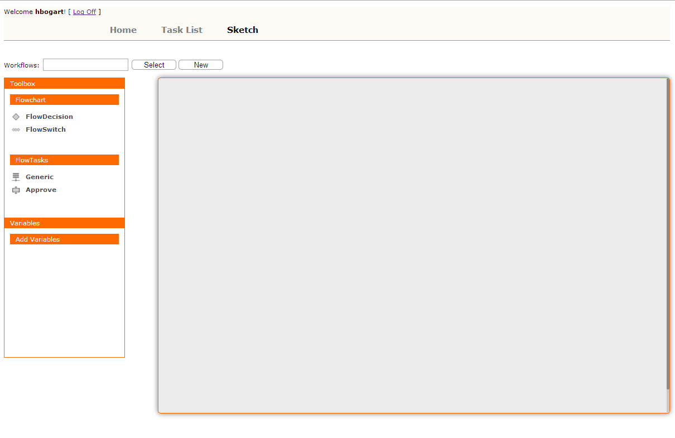

You can use the test user <hbogart, pwd>.

In here you can create your workflow. The tasks “FlowDecision” and “FlowSwitch” are used to control the process flow. “Approve” is a task that require user approval, “Generic” is a task used to perform some system computation.

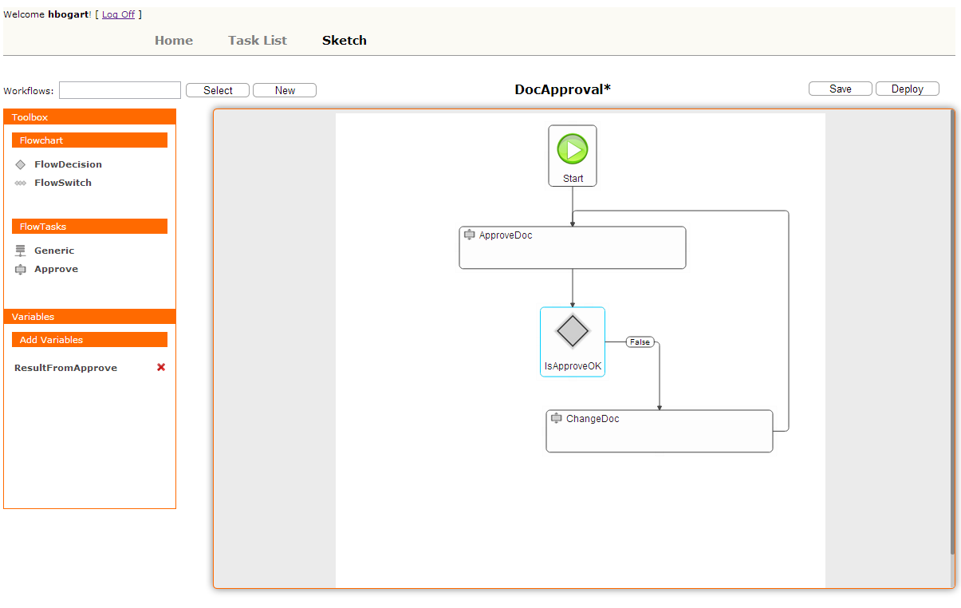

To add a task to the workflow just drag & drop it from the toolbox to the workflow panel. If you double click a task a property pop up window will open.

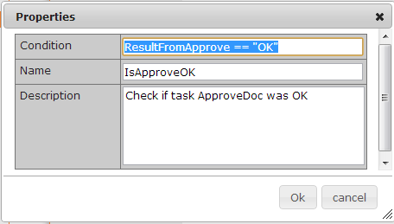

When you’ve finished, save and deploy the workflow.

After you deploy the workflow a new task is created for the development team.

# Development

If you login as a developer <cgrant, pwd> you can see the development task.

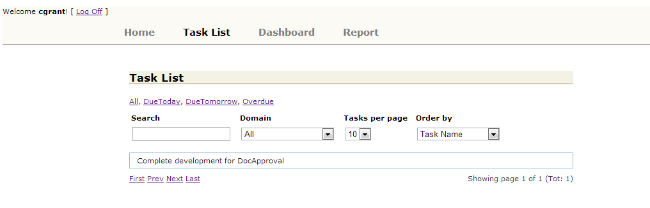

Open the task

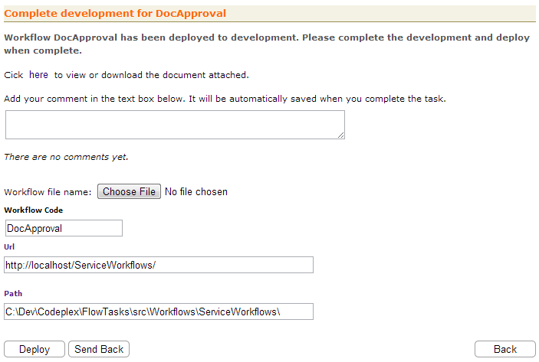

Download the document attached and open it with Visual Studio.

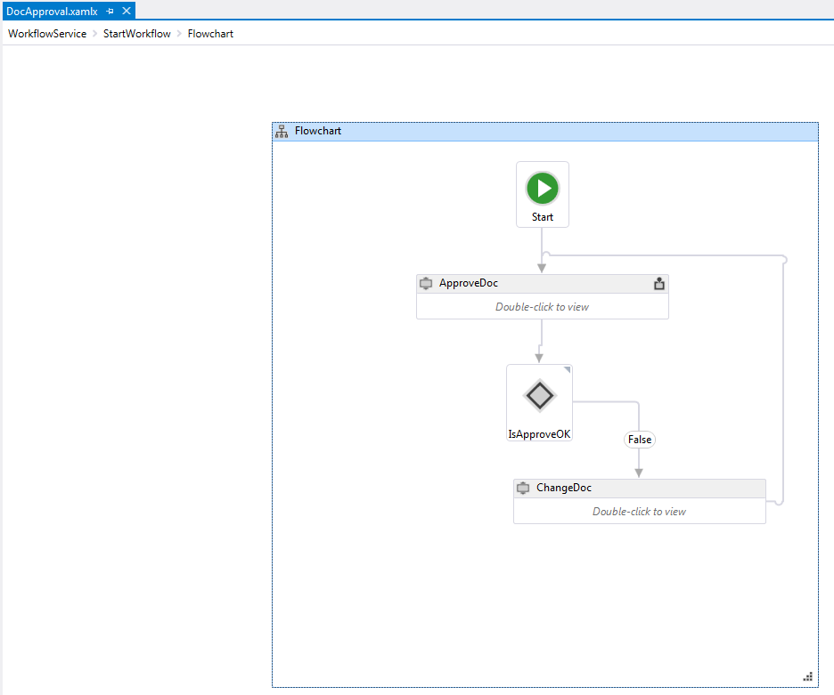

The workflow created in Sketch can be opened with Visual Studio. You could actually make changes in Visual Studio and then load the workflow in Sketch again.

Note that when you load the workflow in Visual Studio you need to open it within a project that has a reference to the assembly “Flow.Tasks.Workflow.dll”.

Finish the development of the workflow in Visual Studio and then deploy the workflow. The application will copy the workflow file to the server for you.

If there is something that you don’t understand or you want more clarification regarding the workflow then you can send it back to the BA team, using the “Send Back” button.

If you do that a new task for the BA users is created.

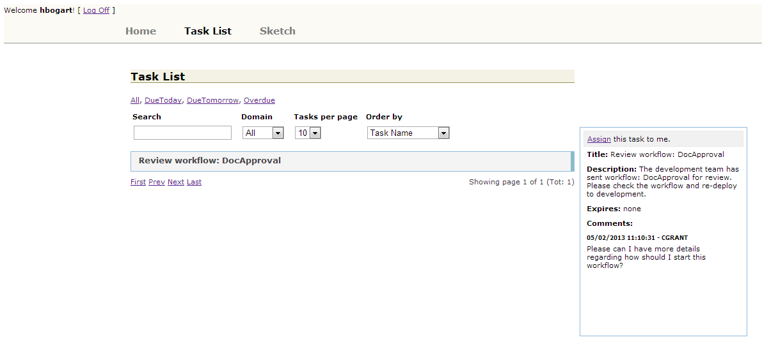

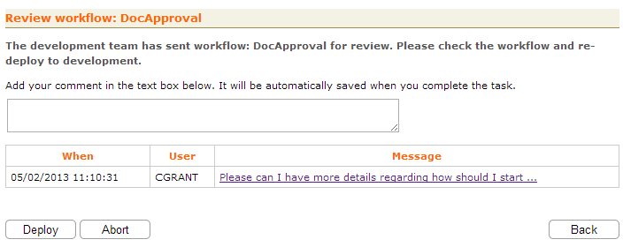

The BA user can make changes to the workflow and then deploy it again to the development team.

# Conclusion

With Sketch you can create workflows without any development knowledge in the same way you would do with a normal office application. The very innovative thing is that the output from Sketch can then be loaded in the development environment of Visual Studio without any change.

This will decrease communication issues between teams and reduce the development life cycle.